**ASSIGNMENT 1**

Q1: Install MS SQL Server  
Ans:

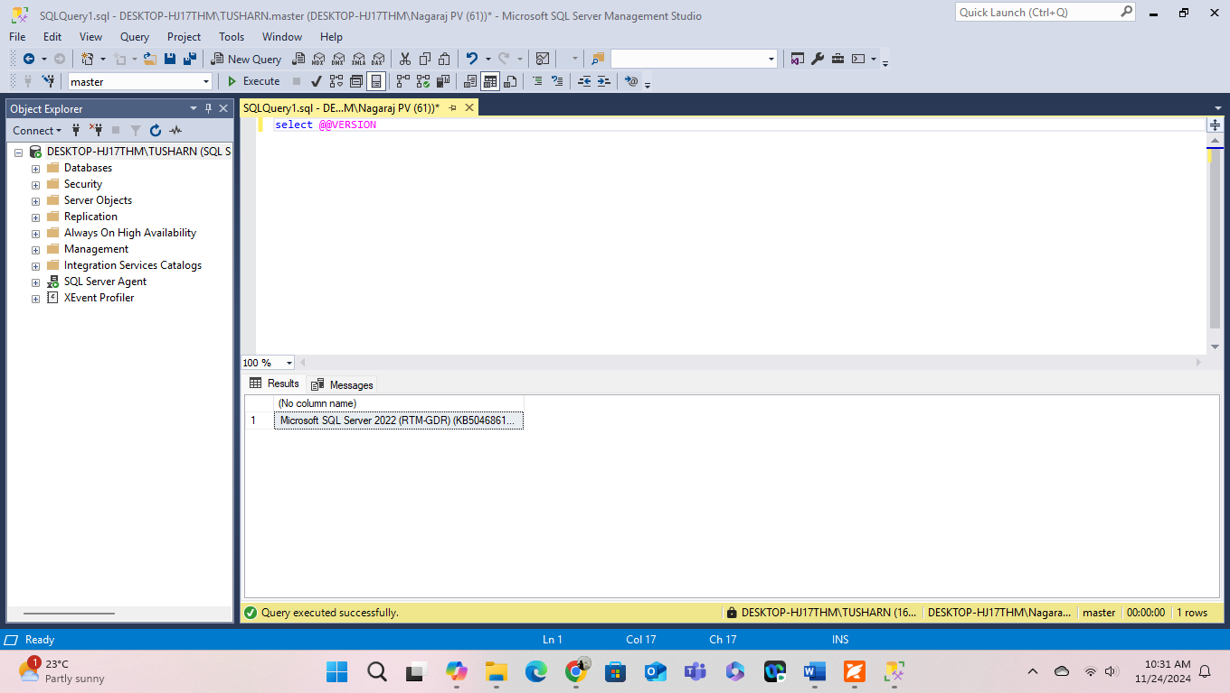

Q2: Give the difference between Char and Varchar data type.  
Ans:

**Char**:-

* A fixed-length data type in SQL Server used to store characters.
* The number of characters is defined at the time of the table creation, and all entries in this column will have the same length. If a string is shorter than the defined length, it will be padded with spaces to meet the length requirement.

**Varchar**:-

* A variable-length data type used to store characters.
* Unlike CHAR, the length of the string can vary, and no extra space is allocated if the string is shorter than the maximum length defined.
* Ideal for columns where the length of data entries can vary significantly, such as names, addresses, or descriptions.

Q3: Explain the types of SQL Commands.   
Ans:

**A)** **DDL (Data Definition Language)**

Defines the structure of the database schema, including tables, indexes, views, and relationships.

**CREATE**: Creates a new table, view, or other database objects.

**ALTER**: Modifies an existing database object, such as adding a new column to a table.

**DROP**: Deletes an existing database object, such as a table or view

**TRUNCATE**: Removes all rows from a table but keeps the table structure intact.

**B) DML (Data Manipulation Language)**

Manages and manipulates data within the database objects defined by DDL.

**INSERT**: Adds new rows of data to a table

**UPDATE**: Modifies existing data in a table

**DELETE**: Removes rows of data from a table

**C) DCL (Data Control Language)**

Controls access to the data in the database by granting or revoking user permissions.

**GRANT**: Gives a user or role access rights to database objects

**REVOKE**: Removes access rights from a user or role.

**D) DQL (Data Query Language)**

Used to query the database for information.

**SELECT**: Retrieves data from one or more tables.

**E) TCL (Transaction Control Language)**

Manages transactions in a database, ensuring that groups of SQL commands are executed together, maintaining data integrity.

**COMMIT**: Saves all the changes made by the transaction

**ROLLBACK**: Undoes all changes made by the current transaction

**SAVEPOINT**: Sets a point within a transaction to which you can later roll back.

Q4: Explain NVARCHAR and NCHAR  
Ans:

* Length handling: NVARCHAR adjusts the storage based on the actual length of the data, while NCHAR always uses the specified length.
* Storage efficiency: NVARCHAR is more storage-efficient for variable-length data because it does not pad the data with spaces, while each character in an NCHAR column takes up 2 bytes of storage, regardless of the actual character content.
* Use case: choose NVARCHAR for variable length data and NCHAR for fixed-length data.